ECE 5650: Project 1



Colin Phlypo

Robert Kruzel

October 2, 2017

**Introduction**

Project 1 was to create a customer data base server using Python 2.7 socket programming based on skeleton code of a class for a database.

**Source Code**

*Refer to .py attachment/code below.*

# ECE 5650: Project 1

# Names: Robert Kruzel, Colin Phlypo

# Program is interpreted correctly.

# Program does not give correct results.

# Explanation: In case of command Search/Remove, customerID is used. Our program was unable to find this therefore,

# outputs no record when the record does exist. Otherwise, program runs correctly

import socket

import sys

class Node: # Customer Record Class

def __init__(self,customerID, customerFirstName, customerLastName, customerPhone):

self.id = customerID

self.first = customerFirstName

self.last = customerLastName

self.phone = customerPhone

def display(self):

# display record

return 'Customer record: ' + str(self.id) + ' ; ' + self.first + ' ; ' + self.last + ' ; ' + self.phone

class customerDB: # Customer Database Class

def __init__(self):

self.db = []

def display(self): # display all records

allRecords = ''

for record in self.db:

allRecords = allRecords + record.display() + '\n'

if (allRecords == ''):

return 'Database is empty!'

else:

return allRecords

def insert(self, record): # insert a record

self.db.append(record)

return 'Operation was completed successfully.'

def remove (self, customerID): # remove a record

found = False

for record in self.db:

if (record.id == customerID):

self.db.remove(record)

found = True

break

if (found):

return 'Operation was completed successfully.'

else:

return 'ERROR: No match was found!'

def search(self, last): # search for all records with the specifiedlast name

found = False

matchingRecords = ''

for record in self.db:

if (record.last == last):

matchingRecords = matchingRecords + record.display()

if (matchingRecords == ''):

return 'ERROR: No match was found!'

else:

return matchingRecords

def show (self, customerID): # show record with specified ID

found = False

for record in self.db:

if (record.id == customerID):

return record.display()

found = True

break

if (not found):

return 'ERROR: No match was found!'

nextCustomerID = 0

cDB = customerDB()

# create customer database

HOST = "10.0.0.5"

PORT = 8889

servSocket = socket.socket(socket.AF_INET, socket.SOCK_STREAM)

servSocket.bind((HOST, PORT))

servSocket.listen(5) #2.7 doesnt assign on no parameter given

serverRunning = True

while serverRunning:

connection, address = servSocket.accept() #blocks here til connection is made

clientActive = True #inner loop exit condition

while clientActive:

mOutSucc = "Operation was completed successfully."

mOutErr = "ERROR: The operation is not supported!"

message = connection.recv(1024)

command = message.split()

if (command[0] == "display"):

mOut = customerDB.display(cDB)

connection.send(mOut)

elif (command[0] == "show"):

mOut = customerDB.show(cDB,command[1])

connection.send(mOut)

elif (command[0] == "insert"):

nextCustomerID = nextCustomerID +1

record = Node(nextCustomerID,command[1],command[2],command[3])

mOut = customerDB.insert(cDB,record)

connection.send(mOut)

elif (command[0] == "remove"):

mOut = customerDB.remove(cDB, command[1])

connection.send(mOut)

elif (command[0] == "search"):

mOut = customerDB.search(cDB, command[1])

connection.send(mOut)

elif (command[0] == "exit"):

mOut = "Connection Closed"

connection.send(mOut)

clientActive = False

serverRunning = False

else:

connection.send(mOutErr)

servSocket.close() #end of program

**Testing Procedure**

To test, the programs were run in two separate command windows. One was the server program and the other was the client program. The process was repeated until bugs/errors were removed. Refer to can screenshots below to see how this was done.

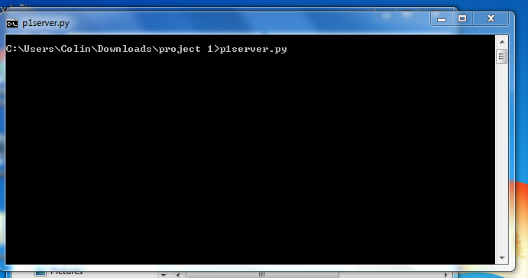

*Figure 1:* Server running in cmd window

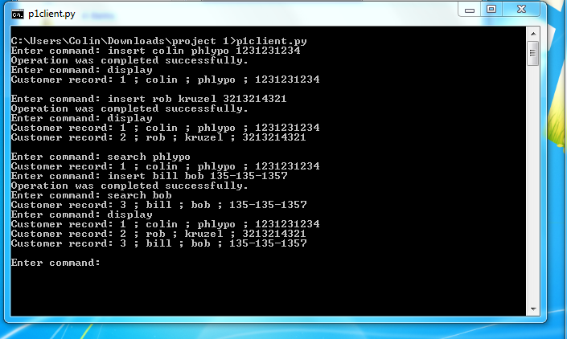

*Figure 2:* Client running in cmd window with error free operations

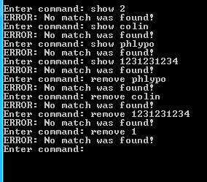

*Figure 3:* Show & Remove commands running in cmd window with error. We believe this is due to error in searching the customerID.

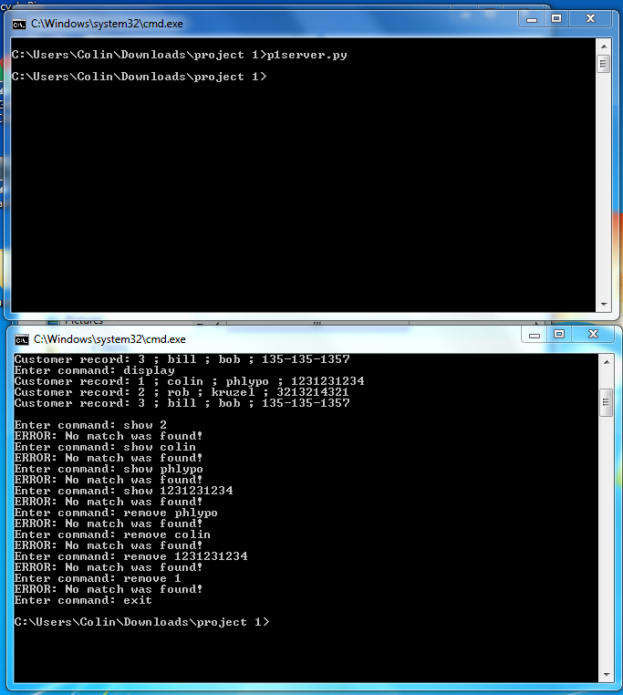

*Figure 4:* Exit command closing python operation in each window.

**Conclusion**

This project was an introductory to socket programming and communicating between a server and a client with python to create and view a customer data base. We were able to send server commands from the client. At the server end, the commands would be split into a usable fashion and distributed to the proper functions with the provided class.